Press Release
Bangladesh Agricultural University

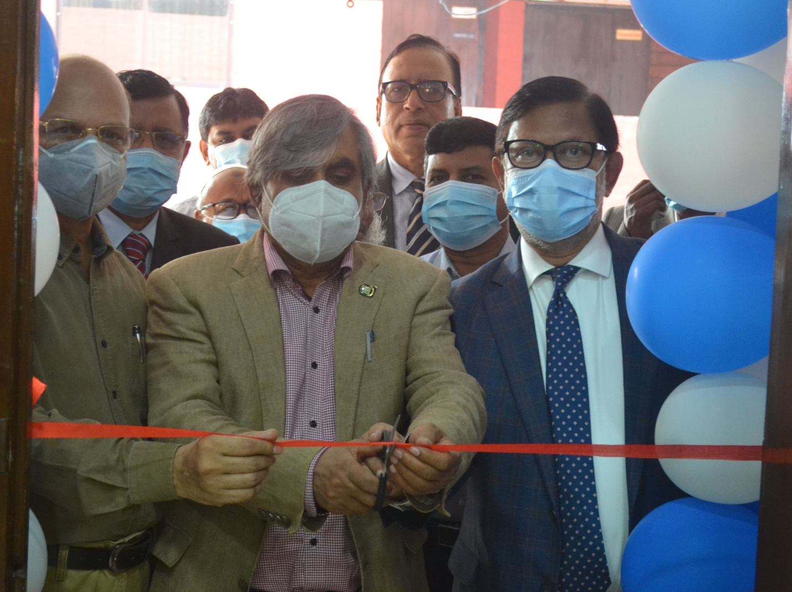
Tractor Cut Section (Courtesy :The Metal pvt Ltd) and Reaper Open Power Transmission System (Courtesy: ASMIH-BD, USAID) were inaugurated by Honorable Vice-Chancellor of Bangladesh Agricultural University Professor Dr. Lutful Hassan, Dr. Md. Nazrul Islam, Dean, The faculty of Agricultural Engineering & Technology ,Professor Dr. Md. Md Monjurul Alam, Director, ASMIH-BD, Md. Sadid Jamil, Managing Director , The Metal Pvt. Ltd and on 22 November 2021. Teachers of the Department of Farm Power and Machinery, Heads of the other Department of FAET ,invited guests were present in the event.

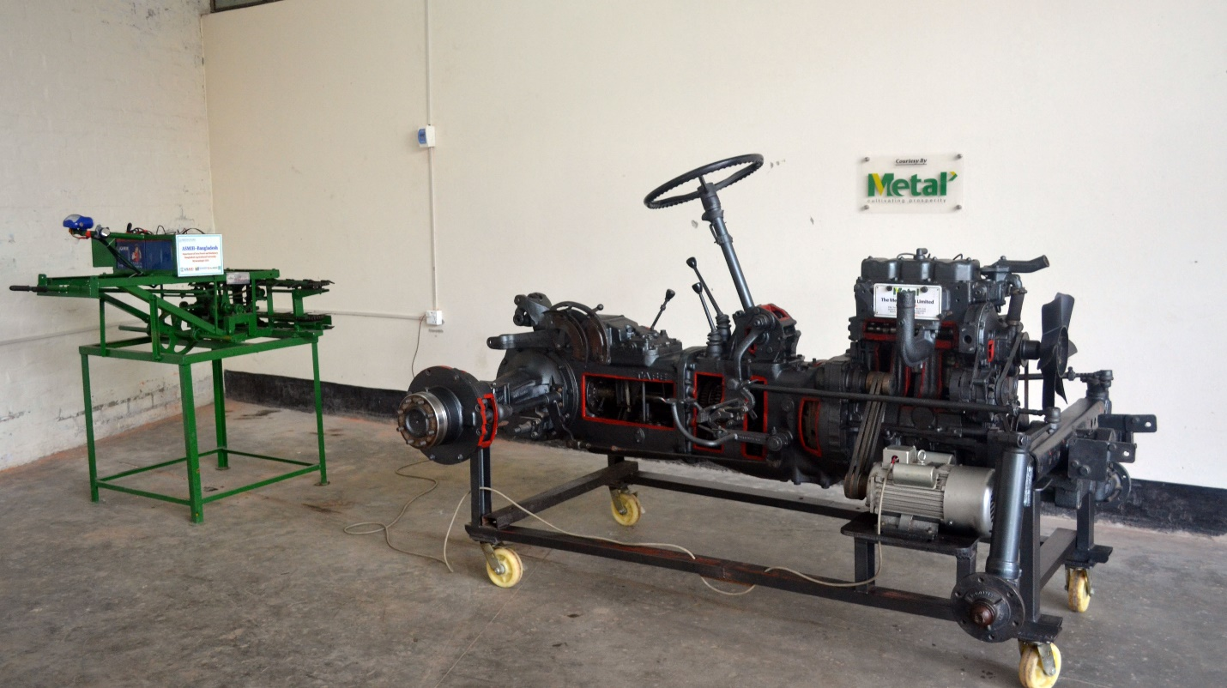
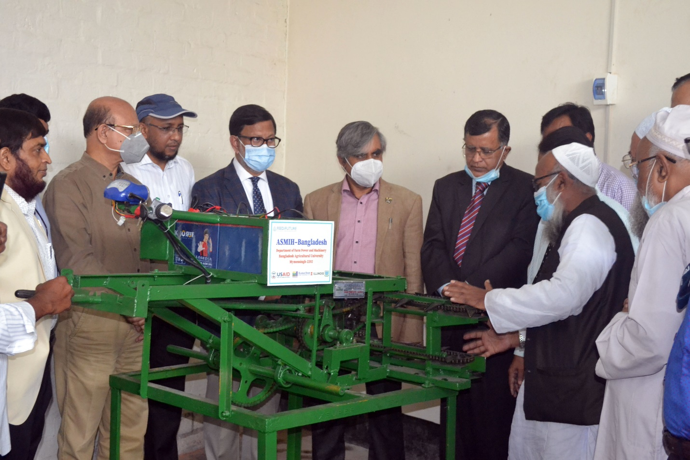

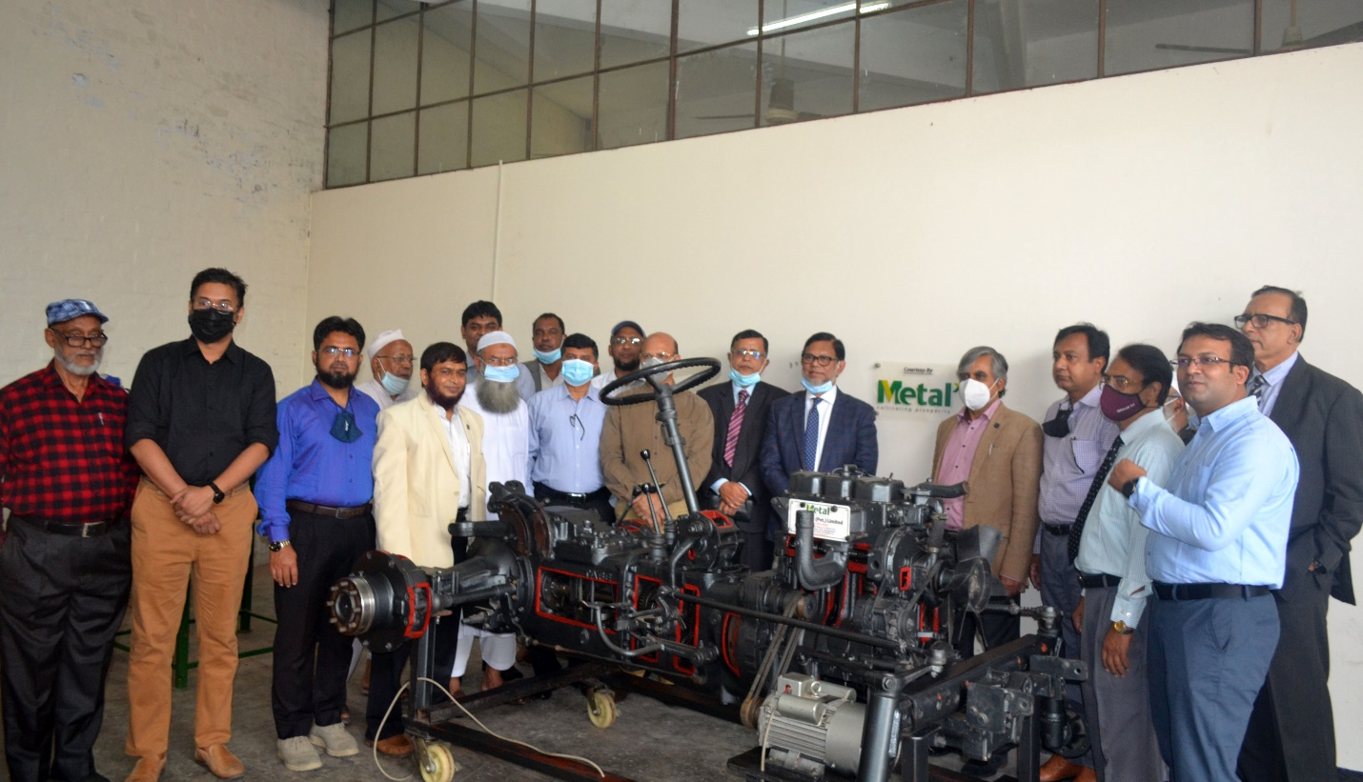

Din Mohammed Dinu
DD,PRP
BAU,Mymensingh
01712198929

